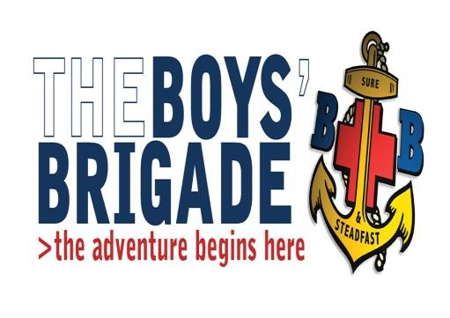
The Boys’ Brigade – North West District Building Your Skills Course
Saturday 7 May 2022
North West District Training Centre

The course is part of the Discover Programme (Company Section), and is for those working to complete the requirements of the President’s Badge. The course is largely practically based and will encourage young people to be more involved in the running and management of their local BB companies. Programmes include: leadership, exercises, role-plays, simulation games and discussions.

The course will be held at the District Training Centre, Carr Lane, Treales, Kirkham, PR4 3SS on Saturday
7 May 2022 commencing at 10:30am and finishing at approximately 4:30pm.

The course fee is £10.00 per applicant including refreshments during breaks and a meal at lunchtime. Cheques to be made payable to The Boys’ Brigade North West District. Alternatively payment may be made by BACS payment, Account numbers are available from the District Office.
The application form below should be returned to the District Office by NO later than 9 April 2022

For any further information please contact David Owens on 07983 501565 or office@bb-northwest.org.uk
- - - - - - - - - -- - -- - - - - - - - - -- - - - - - - - - -- - - - - - - - - -- - - --- - -- - - - -- -
The Boys’ Brigade North West District
Building Your Skills Course
Saturday 7 May2022 at the NW District Training Centre, Treales

Company: ....................................................................................................................................................................................................

Contact Name and Address: ................................................................................................................................................................

.........................................................................................................................................................................................................................

Telephone No: .................................................... Email: ………………………………………………………………………………………….

First Name | Surname | Age  (on 08/05/2022) | Special Requirements  (inc dietary)

